1. The graph of quadratic function $f$ is shown on the grid.  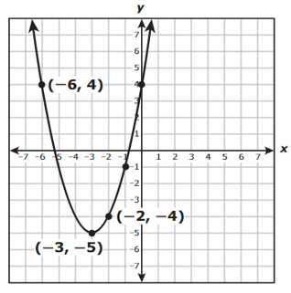  What is the $y$-intercept of the graph of $f?$ | 5. The graph of linear function $g$ is shown on the grid.  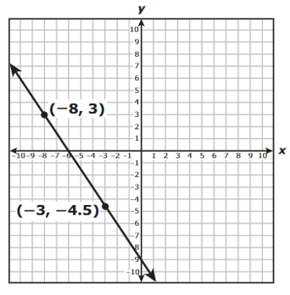  What is the zero of $g$?
2. The expression $(x^{3})(x^{-17})$ is equivalent to $x^{n}$. What is the value of $n$? | 3. The value of $y$ is directly proportional to the value of $x$. If $y=35$ when $x=140$, what is the value of $y$ when $x=70$?
4. What is the positive solution to the equation $0=\frac{1}{3}x^{2}-3$?

